McCracken County has converted to an online process to request Building and Electrical permits. Before you begin the registration process, make sure you have these

1. Access to your email
2. Copy of Workers’ compensation certificate

**TO REGISTER FOR AN ACCOUNT**

1. Go to: <https://us.cloudpermit.com/gov/login> - click REGISTER and enter your email address
2. A link will be sent to your email: click the link and enter your information and create password
3. After you enter your name and address and create your password, you will see “**Create Your First Application**” click that link – this is to complete the registration process
4. Next select Kentucky and McCracken County from the drop-down menus :

1. Select: CONTRACTOR REGISTRATION then CREATE APPLICATION:

1. Select “New Registration” then select the trade that closest describes your business then click NEXT

1. A SUMMARY screen will appear, if no changes are needed, click “Finish & Create”
2. This screen will appear- click “OPEN” in each section to expand:



Enter the requested information for: Application Forms” and use 04.15.2025 as the expiration date of your Business License. Upload the required attachments

1. Once you have completed all the sections, you should have 3 GREEN check marks

1. Click “Submit Application” at the top right of the screen
2. Once you have correctly submitted your registration application, within 24 hours you will receive an email with a Certificate of Contractor Registration. IF you DON’T receive it then your registration is NOT COMPLETE

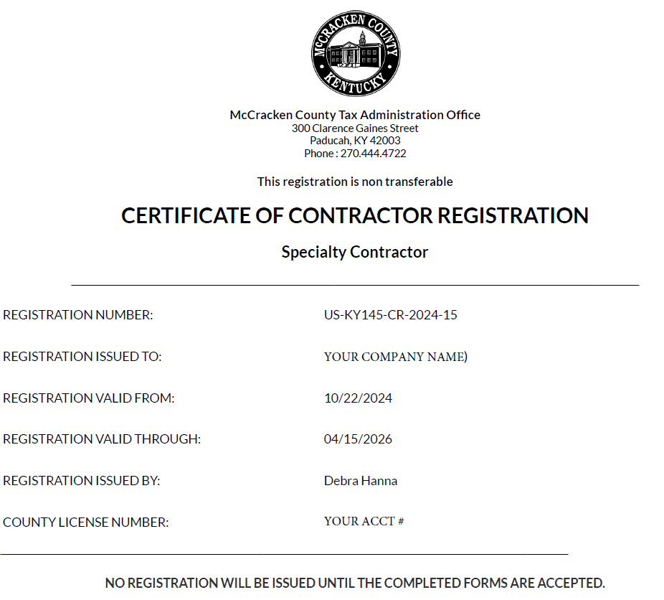

1. If you need assistance call 270.444.4722 and ask for Debbie Hanna or Toni Adams