REQUEST FOR PRICING FOR

TEMPORARY FENCING AT

PADUCAH SPORTS PARK

ISSUED MAY 09, 2025

Sports Facilities Companies (“SFC”) is managing the design, construction and outfitting of the new 120-acre Paducah Sports Park (“PSP”) located in McCracken County, KY. The Owner is the McCracken County Sports Tourism Commission (“Owner”) as supported by the City of Paducah and the McCracken County Fiscal Court. This project is currently under construction. This is an outdoor youth facility comprised of ten full size soccer fields which can be converted into 20 baseball fields. The facility is separated into five distinct areas:
- Championship Field and Downs Road Entry
- The Baseball Diamond facility with four full-sized ballfields with a concession support building
- The Soccer Field facility comprised of 5 full size soccer fields along with a concession support building.
- Dr. Stewart Nelson Park - a centralized recreation park
- An 18-hole Disc Golf course.

BID SPECIFICS
On behalf of the Paducah Sports Park, the McCracken County Fiscal Court is soliciting sealed bids for Temporary Fencing Vendors (“Vendor”). Bid specifications are attached hereto and are available in the offices of the Judge Executives in the McCracken County Courthouse, 300 Clarence Gaines Street, Paducah, KY 42003. All bids must be submitted by 2:00 PM Central on Friday May 23, 2025, to the above office, at which time and place the bids shall be publicly opened and publicly read. The McCracken County Fiscal Court reserves the right to award bids on the basis of lowest and best bid, to alter bid specifications, to reject any and all bids, and to re-advertise for bids.
Owner: McCracken County Sports Tourism Commission
Project: Paducah Sports Park
Project Address 150 Downs Road, Paducah KY 42001
Bid Package: Temporary/Portable Outfield Fencing
Deadline for Questions: May 15, 2025 (5PM Central)
McCracken County Fiscal Court Contact: Steve Ervin servin@mccrackencountyky.gov 270-444-4707
SFC Project Manager: Garrick Griffin ggriffin@sportsfacilities.com Cell: 813-951-2798
Send Sealed Bids No Later Than:
Sealed Bids are to be submitted to Steve Ervin, McCracken County Judge Executives Office, by 2:00pm central, on May 23, 2025. Bid opening will occur @ 2:05 pm central on May 23, 2025, in Meeting Room A at the McCracken County Courthouse.

A. Referenced Project Documents
Vendor must confirm that the project documents below have been received and reviewed:
- Scope of Work and Basis-of-Design for referenced bid package
- Bid Form (240507 PSP Temporary Fencing Bid Form.xlsx)
- Construction Drawings and Specifications ( 250331Paducah Sports Park Full Set.pdf), (Bid Package 01 Specs - FINAL.pdf) (116810-5)
- Temporary Fencing Location Plan (250507 Paducah Location Plan - OUTFIELD PORTABLE FENCING with Key.pdf)
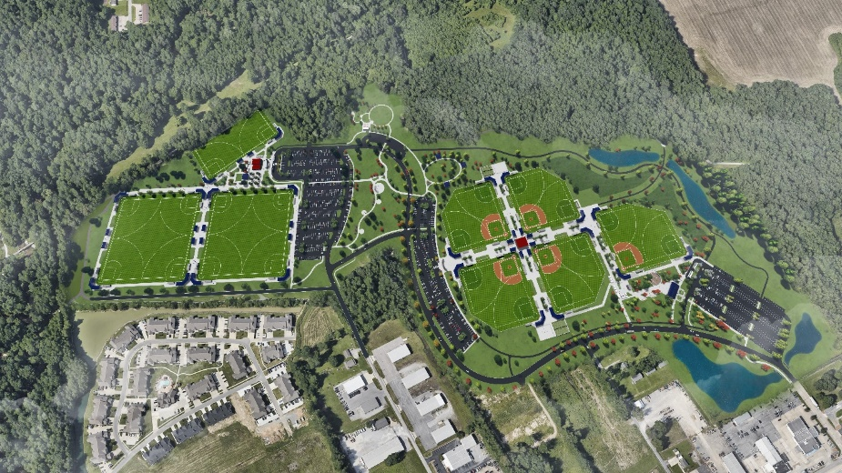
- Contract will be a modified McCracken County Fiscal Court Purchase Order.

B. Required Attachments to Bid
- Bid Form
- Proposed product specifications and details
- Bid details including warranty information.
- Sample COI (Certificate of Insurance)
- W9
C. Bid Form
- The Bid Form may indicate make and models for the basis-of-design for each item. The manufacturer and model listed as the basis-of-design, are solely provided as a convenience to Vendors to best define the desires of the Owner.
- The Bid Form may include quantities, dimensions and other measurements. These are provided as a convenience to the Vendors. Vendors remain responsible for their own quantities and calculations. Vendor must inform Owner of difference between quantities on the Bid Form and Vendor’s quantities.
- Contracts shall be awarded by the McCracken County Fiscal Court to the lowest and/or best bid by a qualified Vendor. In determining best bid, in addition to price, the McCracken County Fiscal Court may consider:
  - The ability, capacity, and skill of the Vendor to perform the contract or provide the service required.
  - The quality of performance of previous contracts or services.
  - The number of days required for delivery and installation.
  - Other items specific to the base bid.

D. Scope of Work
- This document and referenced attachments comprise the Bid Document.
- Vendors shall submit their bids per the attached bid form.
- Vendors agree to furnish all material, transportation, freight, equipment, apparatus systems, labor, and supervision required to do all work in strict accordance with the bid form and scope of work.
- Vendor shall furnish and supply all labor, personnel, service, supervision, skills, permits, licenses, disposal fees, mobilization fees, tools, equipment, lifts, rigging, apparatus, gaskets, bolts, hardware, parts, supplies, material, incidentals, travel time, transportation, fuel surcharge, tariffs, shipping, and documentation necessary to complete the specified work.
- The McCracken County Fiscal Court is exempt from Kentucky State Sales Tax.
- Bids shall include all assembly, testing and demonstrations.
- Vendors should review Specification Section 116810 – Athletic Field Equipment and Structures for Basis-of-Design. Alternate manufacturers are acceptable.
- Furnish and install temporary fencing per plans and specifications.
Project Timelines
- Proposals Due Date: May 23, 2025, 2:00 PM CENTRAL,
- Upon request, Vendor shall provide formal submittals for all equipment no later than Twenty-one (21) days after executed contract. Submittals will be reviewed by Owner’s Architect/Engineer Team.
- Projected delivery date: Commencing on or about October 01, 2025.
- Projected installation date: Commencing on or about October 01, 2025
- Projected acceptance Date: No later than December 19, 2025
Terms and Conditions
- Please contact Steve Ervin (270-444-4707) for pre-bid site visit.
- Any and all subcontractors are subject to the approval of the Owner.
- Vendor shall submit a valid McCracken County business license prior to executing an agreement.
- Upon request, Vendor shall submit a certificate of $1,000,000.00 liability insurance naming McCracken County, City of Paducah and McCracken Sport Tourism Committee as additionally insured. The bid should meet all insurance requirements set forth in the referenced project documents.
- All work must be completed by the specified date stated here within.
- Vendor shall not begin any work activity until such time as a Purchase Order has been received from the McCracken County Fiscal Court. Contracts shall be awarded by the McCracken County Fiscal Court to the lowest and/or best bid by a qualified Vendor.
- Vendor shall identify any and all requirements necessary for maximum performance of equipment to meet the design intent on the goods being provided.
- Vendor must be fully equipped and capable of meeting all specifications and requirements of this bid.
- All custom elements require the written approval of the Owner.
- Vendor pricing must include all engineering and surveying required to perform work unless noted otherwise.
- Vendor shall comply with all applicable State and local laws, ordinances, codes, and regulations.
- The bid shall include all applicable permits, licenses, etc. related to this work of scope.
- Prior to scheduled commencement of the project and associated work, a meeting will be conducted at the project site or other designated site by Owner with the Vendor and any other persons directly involved with the performance of the work. No work will commence before consulting with the Owner. The Owner must approve the actual work schedule of the Vendor to ensure that no disruption or interferences with operations will occur.
- Provide unloading and staging within the Owner approved areas.
- Abide by schedule and installation dates as approved by the Owner. All delivery and installation schedules must be reviewed by the General Contractor and approved by Owner.
- Provide all warranty and close-out information.
- Perform turnover inspection and walk-throughs, training sessions, and startups.
- Coordinate with and attend meetings as reasonably required by the General Contractor and Owner.
- Prior to submitting a bid, the Vendor shall examine all documents relating to this project and become familiar with the job site to ascertain the nature of the work and the character of the job site. The Vendor shall become familiar with the contractual requirements, project limitations, and various aspects of the work, physical conditions and surroundings of the job site. The Vendors shall include in their bids a sum sufficient to cover the costs of doing the work under the existing site conditions and project requirements. By submitting a bid for the project, the Vendor declares that he or she has thoroughly investigated the job site, examined all related project documents and is familiar and satisfied with the nature, character and condition of the project site, contractual requirements, project limitations and the various aspects of this project. Owner will not consider any claims for compensation whatsoever on account of the Vendor’s failure to fully investigate and examine the project requirements and job site conditions as required above.
- All material, parts, supplies, and/or product utilized for this project shall be new and unused, unless expressly accepted by the Owner in writing.
- Technical and Descriptive Literature: Vendors shall include the complete manufacturer’s technical and descriptive literature regarding the brand and material your firm is proposing to utilize for this project. Literature shall be sufficient in detail in order to allow full and fair evaluation of the bid.
- Materials, supplies, services and parts requested by Owner must be of the highest quality and must conform to any related state, municipal or federal standard and be consistent with standard commercial practices.
- All services provided and performed under this Project shall be, unless otherwise stated in the contract, shall be in accordance with the methods and procedures of the industry’s highest standards.
- Vendor shall complete all work in a neat and workmanlike manner, to the satisfaction and direction of the Owner.
- Failure to comply with requirements stated in the Bid Document will result in the termination of contract due to non-performance.
- Vendor products and systems must be of the highest quality and must conform to any related state, municipal or federal standard and be consistent with standard commercial practices.
- Invoicing Requirements: All invoices shall include, but not be limited to the following information:
  - Form and timing acceptable to the Owner ·
  - Purchase Order Number
  - Service Description
  - Total Cost of Services
  - Invoice shall be sent to the address stated on by Owner.
  - Conditional Release of Lien will be required for all invoices.
  - Unconditional Release of Lien will be required for all payments.
  - Vendor shall file all required UCC forms with payments, documents required by Owner and assist the Owner with documents related to payment requests and payments.
  - Vendor will provide invoices in a form acceptable to the Owner including necessary support documentation such as W9 forms, insurance certifications, vendor information forms and Release of Liens.
- Warranty Coverage: All repairs, refurbishments, material, parts, equipment, labor, installation, craftsmanship and workmanship, shall be fully warranted and guaranteed for a minimum of one (1) year (parts, service, labor and travel time) from the date of final acceptance by Owner. If the replacement parts, materials, etc., utilized for this project is covered by a standard manufacturer’s warranty greater than one (1) year then the Vendor must extend that coverage to Owner. Any additional repairs and services required within the warranty period will be at the expense of the successful Vendor. All material, supplies, parts, etc., will be replaced at no additional cost to Owner. The Vendor is required to expressly warrant that all items are new and free from defects, warranted for their merchantability. Vendor shall respond to all complaints within three (3) business days from the initial call. Failure to do so may result in cancellation of future contracts with Owner. This warranty shall not void the Manufacturer's warranty for quality or durability. Vendor shall provide Owner a copy of the manufacturer's warranty, signed and executed by an authorized manufacturer's representative.
- Vendor shall provide extended warranties, service agreements, maintenance agreements and/or other post installation services as optional services for Owner’s sole review and acceptance.
- Payments and performance bond is not required with base bid. Owner reserves the right to request and compensate the cost of payment and performance bond at any time.
On site activities and installation requirements
- The bid shall include all necessary hoisting, rigging, scaffolding, staging, temporary safety protection, material hoisting, equipment, and small tools necessary to perform the referenced scope of work. All equipment and activities must meet OSHA standards. Provide safety manual and site-specific plan upon request.
- Vendors must follow the General Contractor’s safety program and OSHA requirements when on the site. Bid shall include safety meeting attendance as required by site conditions.
- Vendor must adhere to all safety regulations associated with the job being performed and provide copies of employee training records and safety programs as requested by Owner. Vendor shall train employees on Owner’s emergency and evacuation procedures prior to starting job.
- Vendor will not perform any work that may result in health hazard or offensive conditions or adversely affect Owner’s business continuity.
- Bids to include all necessary blocking, backing, and supports for Vendor’s installation.
- Bids shall include any storage or lay down requirements for material on site to complete work.
- Bids shall include necessary mobilizations required for scope of work.
- Bids to include protection of existing building conditions and finishes at time of installation.
- Vendor shall maintain a credible work force daily to ensure progress of job. Vendor shall employ only skilled personnel, knowledgeable of all phases of the project. A superintendent or supervisor shall always be on the job site when work is being performed. At no time shall any non-skilled laborers or helpers be left on the job unsupervised.
- Vendor shall secure all equipment, tools and related materials while working in the facility against the occurrence of theft, accidents, injuries or damage to any person or property at all times.
- Vendor shall maintain sufficient safeguards against the occurrence of accidents, injuries or damage to any person or property around the project or work site. Barricades, caution tape and/or signs shall be placed around all work areas.
- Any damage to existing utilities, building, finished surfaces, equipment, City or public property or improvements, resulting from the performance of this contract shall be repaired to the satisfaction of Owner at the Vendor’s sole expense. The repair or replacement work shall be of equal or greater quality and in appearance to prior condition. If damage caused by the Vendor is repaired or replaced by the Owner, the cost of such work shall be deducted from the monies due the Vendor.
- Excess materials, rubbish, garbage, rags, debris, etc., generated from the Vendor’s activities shall be disposed of off-site by the Vendor daily at the Vendor’s own expense. Any material needing removal is to be disposed of off-site in a safe and legal manner. The Vendor shall not stockpile debris, rubbish, garbage, excess materials or other unwanted materials on the sidewalk or on the street. Washing of excess materials into the storm drain is prohibited. Payment for transportation and disposal of excess materials and removed equipment shall be included in the contract and no additional compensation shall be made.

E Bid Alternatives
Vendors must provide a base bid to comply with the stated Basis-of-Design. Vendors may provide pricing for alternate products as voluntary alternates. All voluntary alternates are subject to the sole review and acceptance by the Owner.

Steve Ervin, Project Manager, 270-444-4707
McCracken County Courthouse
McCracken County Judge Executives Office
300 Clarence Gaines Street Paducah, KY 42003

-End-

